

VR Physics Lesson: Buoyancy

HCI Project Part 1

11.05.2023

Ryan Woodward, Jonathan Moore, & Nathan Kennedy

Grand Canyon University

CST320 - Human Computer Interaction

Dr. Isac Artzi

Table of Contents

Introduction……………….…………………………………………………………………………….2

Software & Tools Used..…………………………………………………………………………….3

Application’s Features………………………………………………………………………………4

Appendices…………………….…………………………………………………………………………5

Introduction

Our Unity VR project, *Buoyancy Physics Lesson*, is designed to provide an engaging and interactive learning experience centered around the fundamental physics principle of buoyancy. In Unity’s captivating virtual environment, users will receive a hands-on learning experience as they experiment with floating & sinking objects in a fluid medium. Through hand-on experience, visual simulation, and guided learning, users will be able to immerse themselves in learning about physics.

Software & Tools Used

For this project the primary tool we have leveraged is Unity and its associated tools. For instance we have greatly leveraged Unity’s assets store and its Universal Render Pipeline (URP) to develop the application. However, other critical tools have been those related to collaboration, development, source control, and application design. Tools such as VS code, Canva, LucidChart, Jira/Confluence, Discord, Plastic SCM, and discord for scripts.

* Unity (VR Application Development)
* VS Code (Code Development)
* Discord (Communication)
* Lucid Chart (Application Flow Diagram)
* Canva (Storyboard)
* Jira & Confluence (Project management & Collaboration)
* Plastic SCM (Source control for Unity projects)
* GitHub (Source control for C# scripts and unity assets)

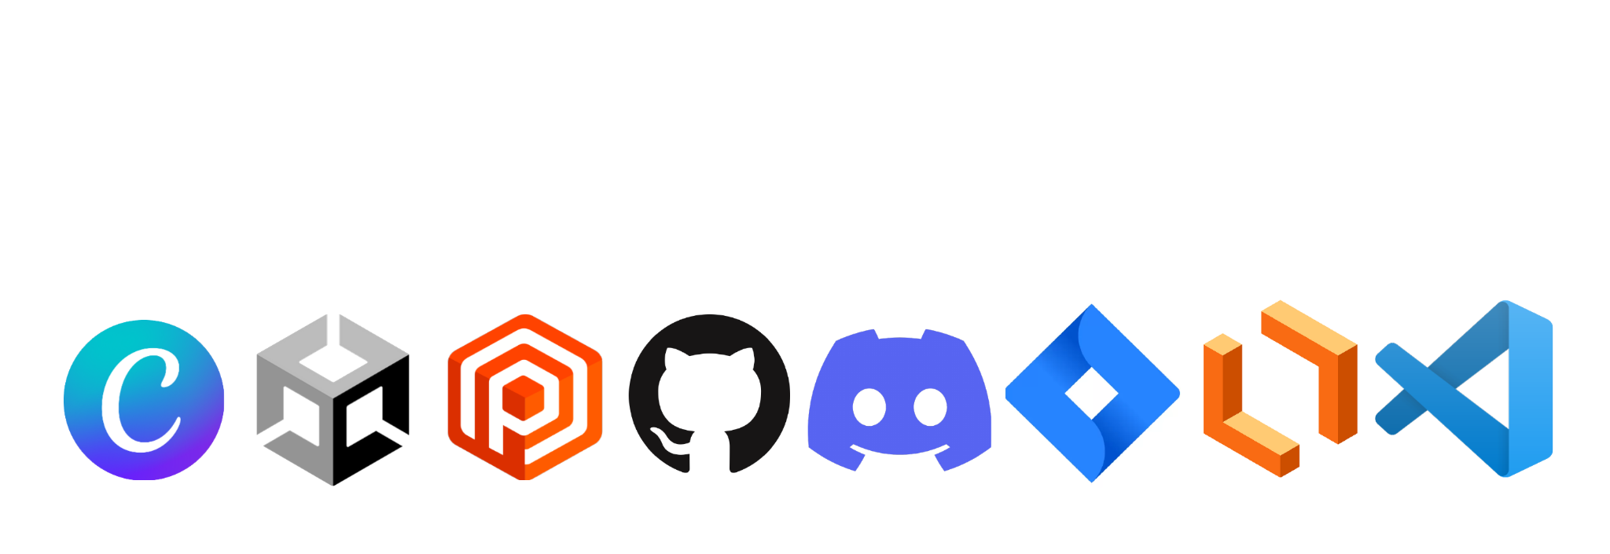

Application’s Features The Buoyancy Physics Lesson application consists of several key components that, together, allow us to provide a comprehensive learning experience for our users. First, is the use of guides (in the form of Unity canvases) to allow the user to become acquainted with the objective of the application and familiar with the VR environment and controls. Second, is the objects and interactions within the scene. The objects, such as primitives, are *interactables,* meaning the user can perform some actions on them (ie. pick up). Other components include physics scripts that allow the water assets to properly mimic water such that objects placed in the water will behave as though they would if they were not virtual. These assets (canvases, tutorials, primitive objects, and scripts) allow our users to learn the principle of buoyancy in an intuitive manner.

* Canvases that illustrate and explain the principle of buoyancy
* Canvases that describe & illustrate the VR experience and controls
* Primitive (interactable) objects that permit the user a hands on experience as they experiment with the principle of buoyancy
* Physics scripts that make the experience realistic and feasible.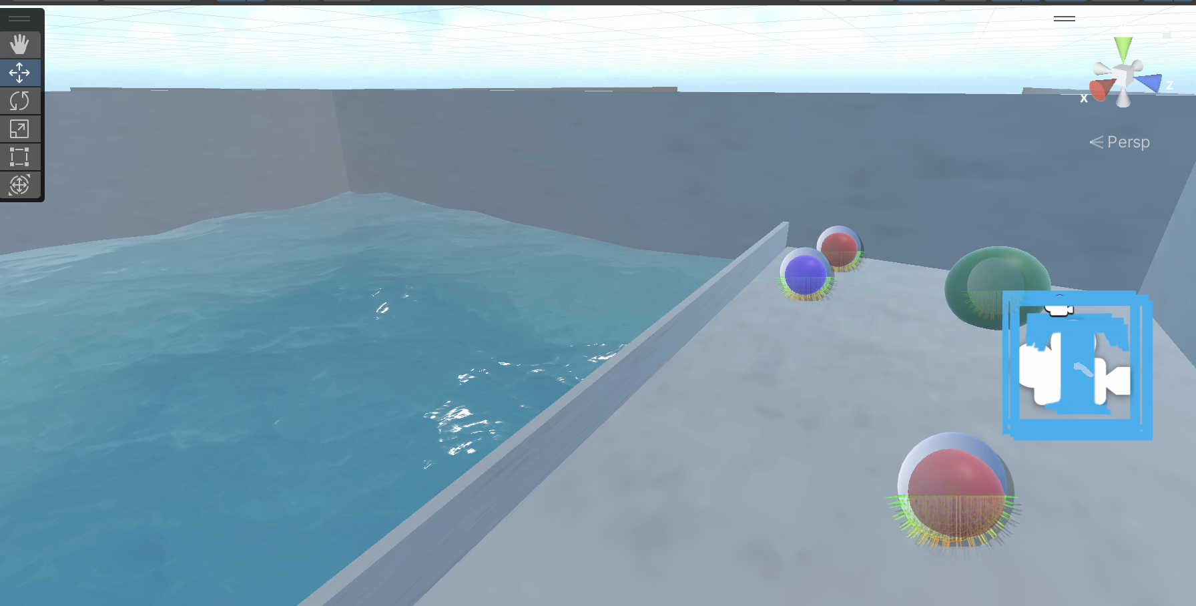

*Fig1. Screenshot of Unity scene*

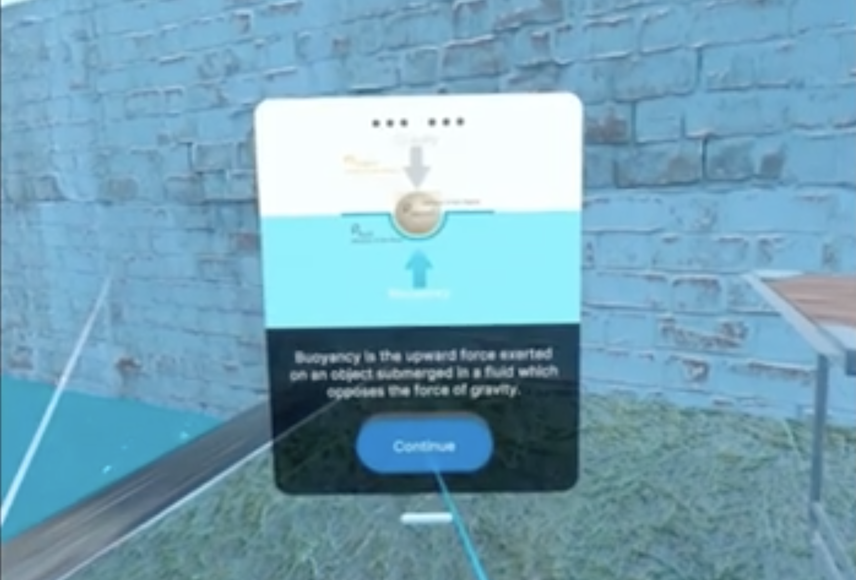

*Fig2. Screenshot of UI cards*

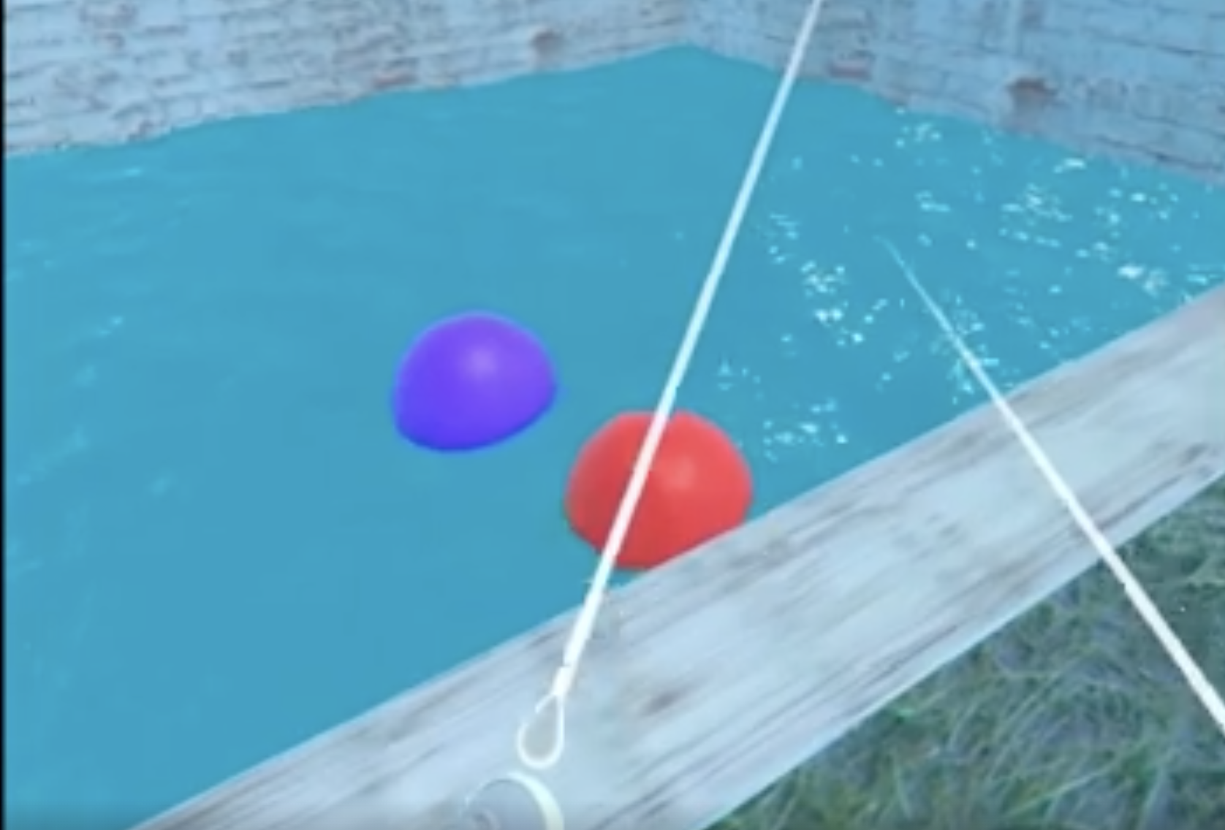

*Fig3. Screenshot of Buoyant Objects*

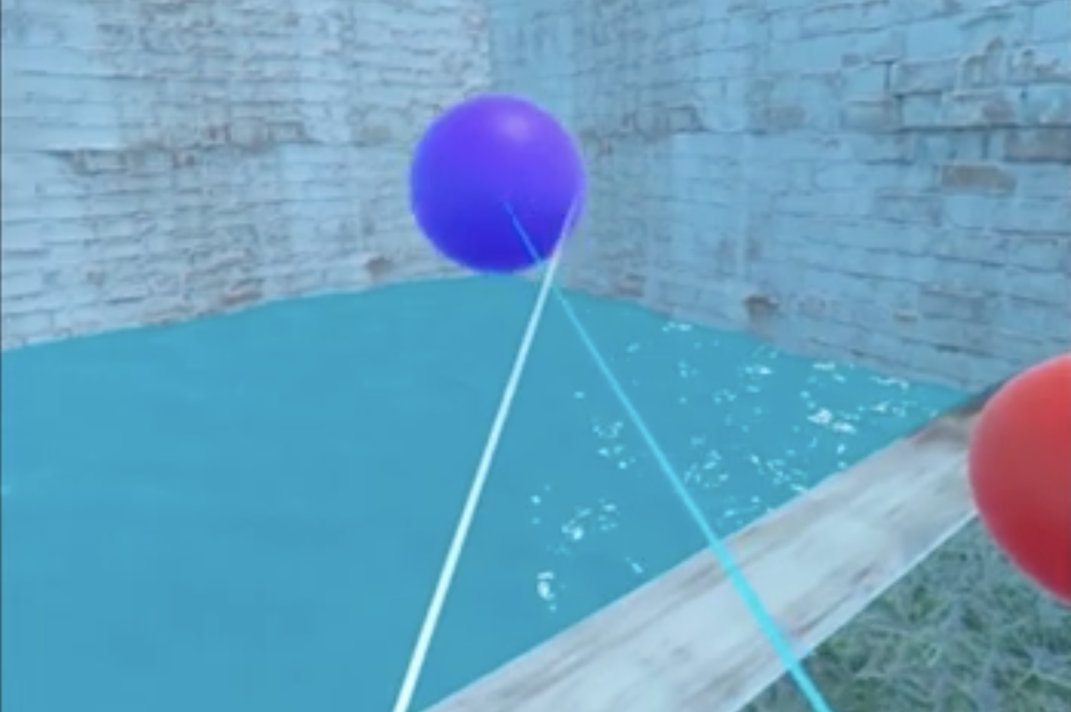

*Fig4. Screenshot of User Holding Object*

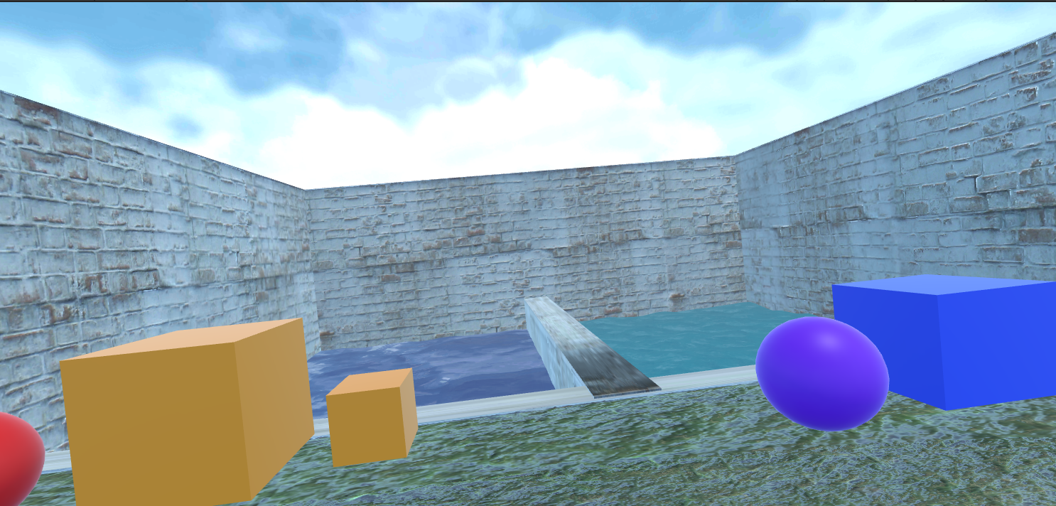

*Fig. Screenshot of User In Scene 3*

Appendices

**Screencast Presentations:**

* Ryan Woodward
  + <https://youtu.be/DCawzhAXeG4>
* Johnny Moore
  + …
* Nathan Kennedy
  + <https://www.loom.com/share/d6c940acf8c04a969b288b3ea304f3ef?sid=b5613281-2615-4280-8777-5e565b5297cf>

**Demonstrations:**

* Tutorial Scene Demo
  + <https://youtu.be/JYBlsDfexLI>
* Johnny Your demo here
  + …
* Nathan your demo here
  + <https://www.loom.com/share/a6eb0d80580f41949c62301ed7774412?sid=c88cd473-bc2b-42c1-a71e-b18812252bc9>